Week: 9
Experiment: 6

Part:1
“To Study Stomatal Structure and Distribution in Various Leaf Species Placed Under Light and Dark Conditions.”

1) Lab Performance (10 Marks):

2) Total Marks (20 Marks):
3) Observation (8 marks):
Sample | Total no of Stomata observed | No closed stomata | No open stomata
Leaf 1  Sunlight (Upper epidermis) | 1 | 0 | 1
Leaf 2  Sunlight (Lower Epidermis) | 18 | 3 | 15
Leaf 3  Dark (Upper Epidermis) | 0 | 0 | 0
Leaf 4  Dark (Lower Epidermis) | 15 | 7 | 8

DARK UPPER SIDE:-
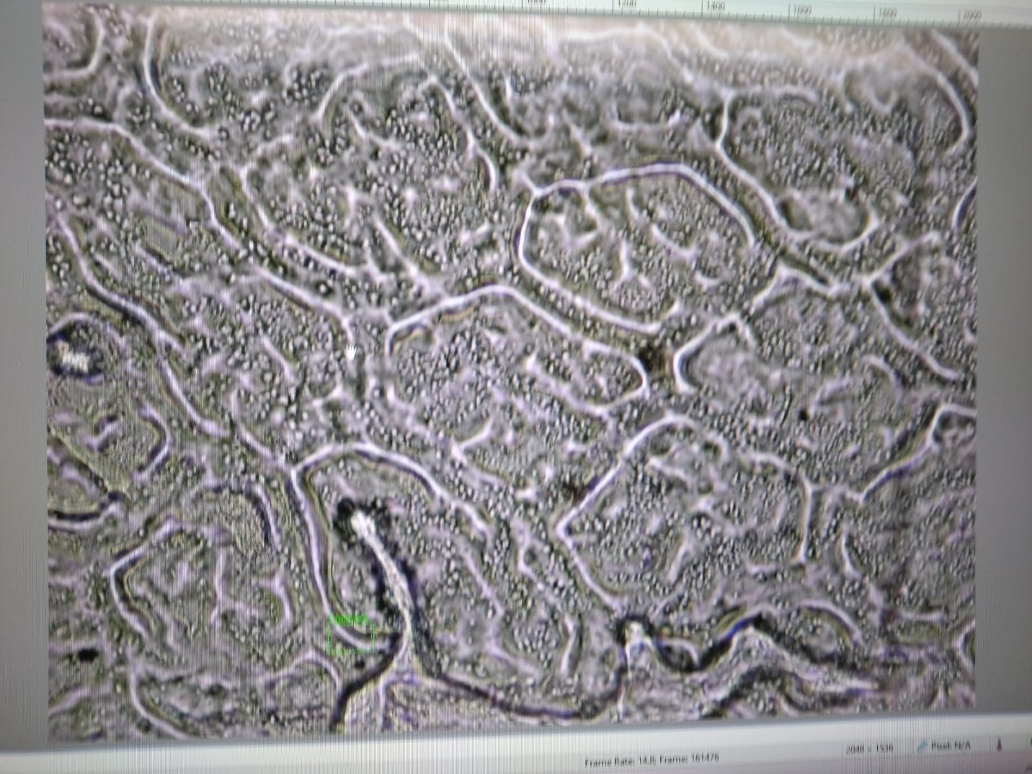
LIGHT UPPER SIDE:-
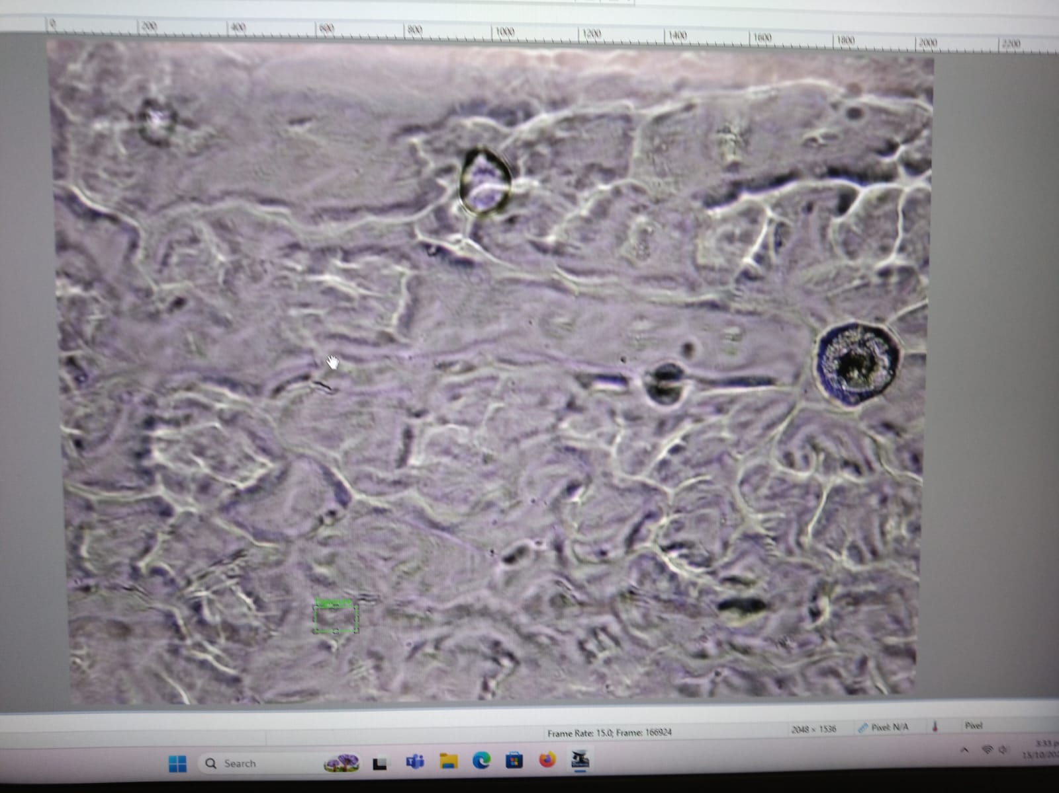

LIGHT LOWER SIDE:-
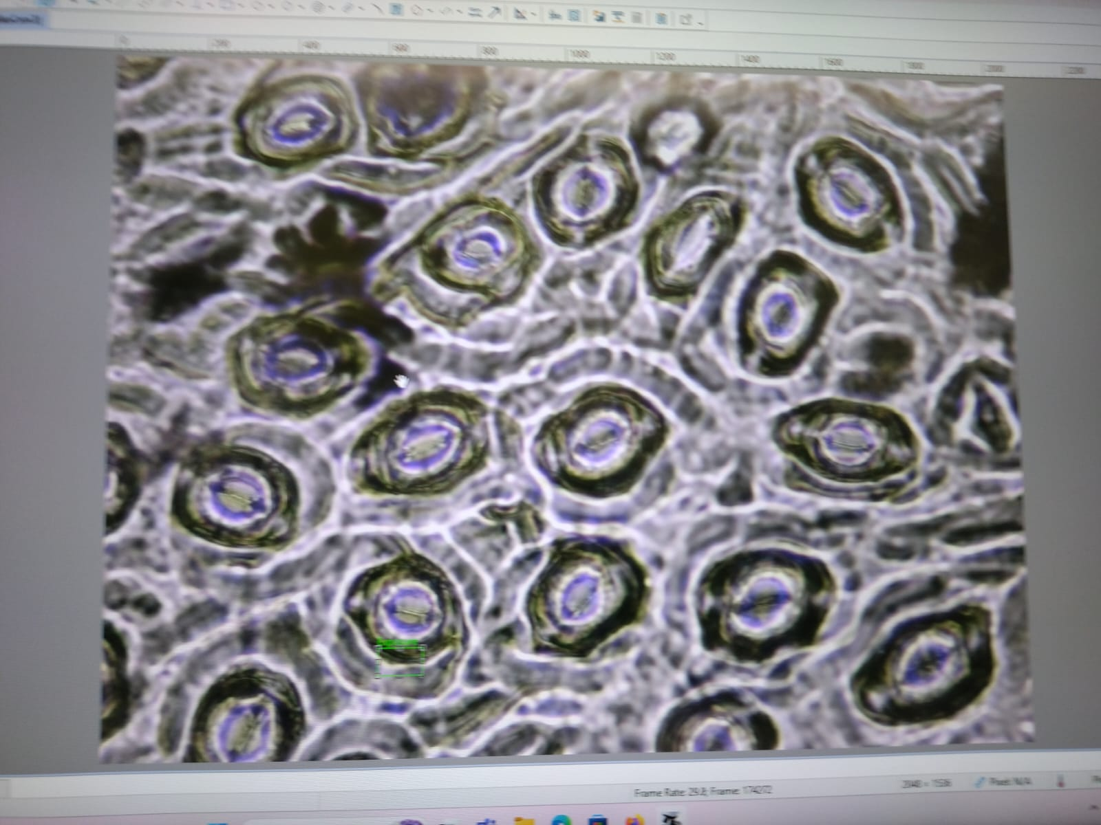
DARK LOWER SIDE:-
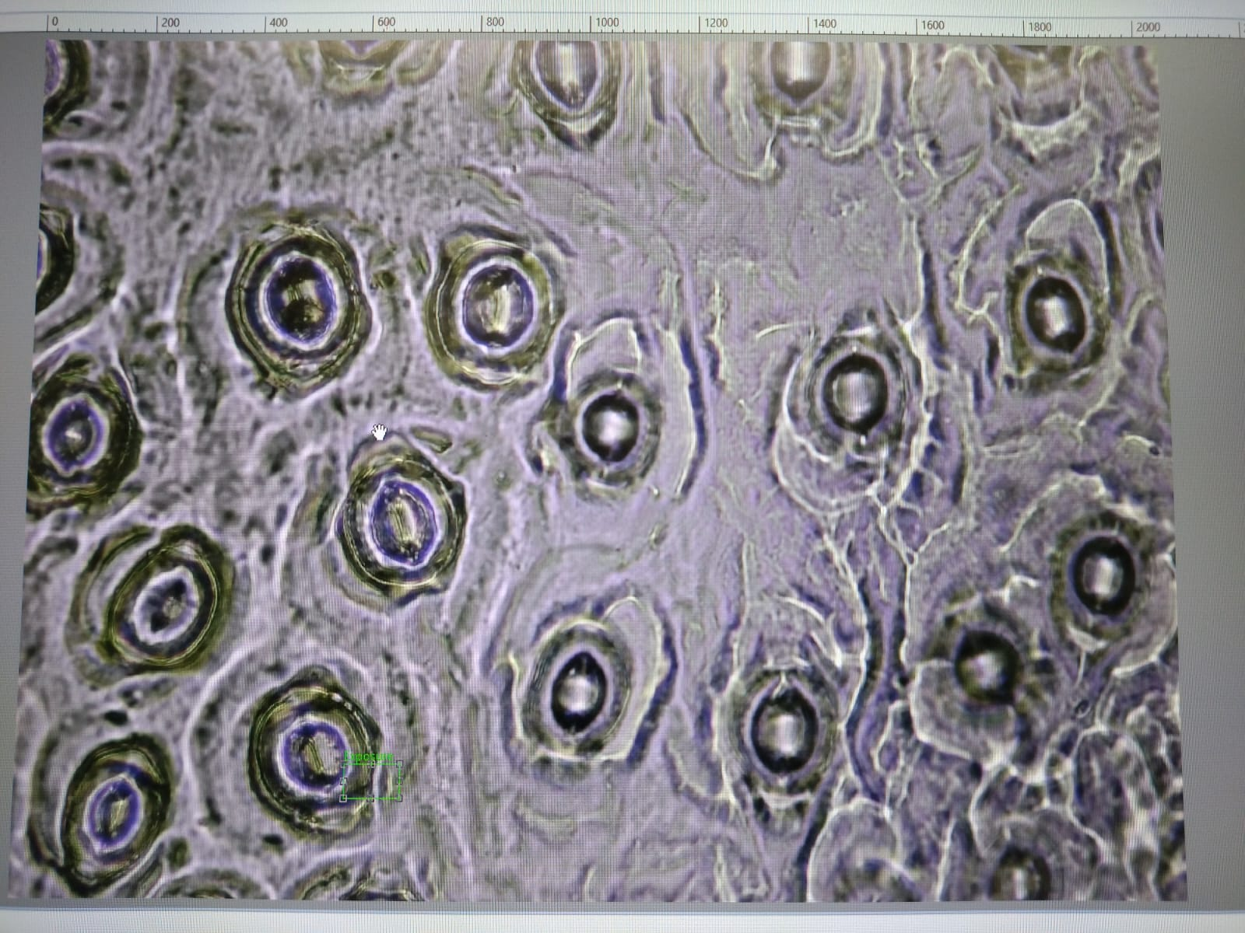
4) Result (2 marks):
Stomatas are usually found in the lower epidermis or underside of the leaf. Stomatas are usually close in light and open in dark environment.
Part: 2
“To Separate Pigments, Present in Leaves That Are Useful in Photosynthesis Through Paper Chromatography.”
5) Observation (4 marks):
S. No | Name of the extract | Color of the spot | Distance traveled by the spot from the original line. | Distance traveled by the solvent from the original line | R_{f} Values
1 | Chlorophyll A | Yellow- Green | 10.2 | 16.0 | 0.64
2 | Chlorophyll B | Green | 13.0 | 16.0 | 0.81
3 | Xanthophylls | Yellow | 16.0 | 16.0 | 1.00
4 | Carotenoids | Not observed | 0.0 | 16.0 | 0.00

6) Picture showing pigments chromatography performed by the group (1 mark):

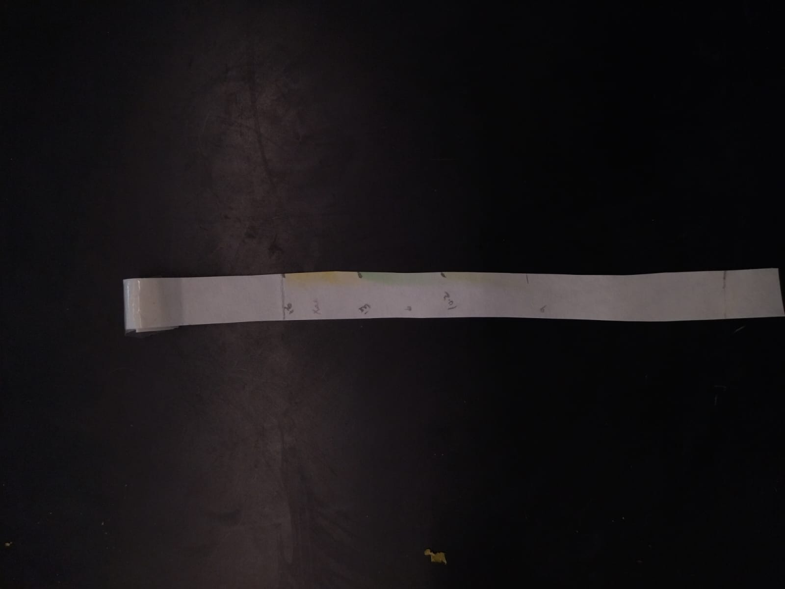
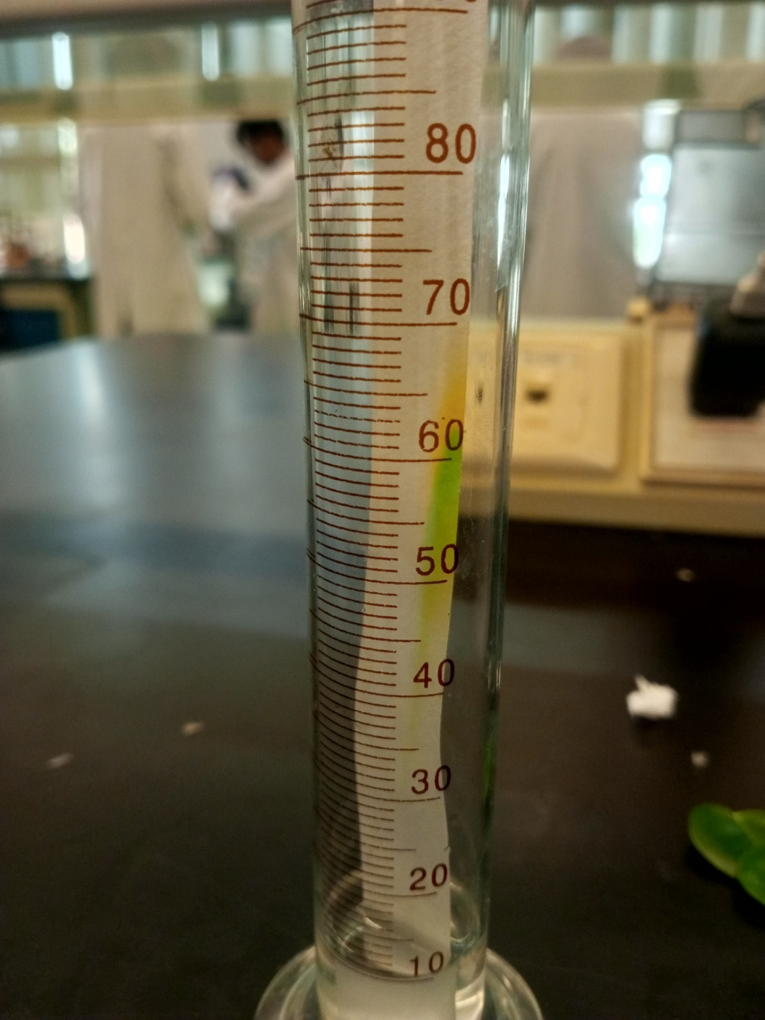
7) Calculations (4 marks):
For quantitative analysis, calculate the Rf (retention factor) values for each pigment:
Rf=$\frac{Distance traveled by the pigment}{Distance traveled by the solvent front}$

- ​Distance traveled by the pigment: The distance from the baseline (where the pigment was initially spotted) to the center of the pigment band on the chromatogram.
- Distance traveled by the solvent front: The distance from the baseline to the farthest point the solvent reached on the paper.

For Chlorophyll A:
$$Rf=\frac{10.2}{16.0}=0.6375≈0.64$$
For Chlorophyll B:
$$Rf=\frac{13.0}{16.0}=0.8125≈0.81$$
For Xanthophylls:
$$Rf=\frac{16.0}{16.0}=1.00$$
For Carotenoids:
$$Rf=\frac{0.0}{16.0}=0.00$$
8) Results (1 mark):
Different pigments in the leaf extract travelled different distances on the chromatogram due to differences in their solubility and affinity to the solvent.
Xanthophylls showed the highest Rf value (1.00), indicating the greatest solubility in the solvent.
Chlorophyll B and Chlorophyll A showed moderate Rf values (0.81 and 0.64 respectively).
Carotenoids were not clearly observed.
The separation successfully demonstrated the presence of multiple pigments involved in photosynthesis.
9) Problems:
We dipped the solvent paper unevenly so chromatography was observed on the side of paper rather than in middle. If the pigment spot applied on the chromatography paper was too large or uneven, it could have caused overlapping or spreading of colors. Measuring the distance traveled by the solvent or pigment bands with a ruler could introduce small errors, especially when bands are faint or unclear.

